Robert B. Kiholm
Atmo-1010
Christopher Foster, PhD
Spring 2020
Weather and Your Major
My major is going to be computer aided drafting and design, so I thought I would incorporate computer images related to the topics we studied this semester. 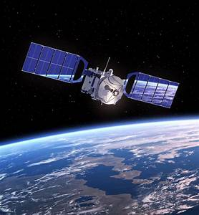 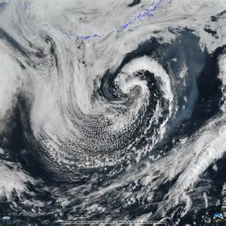
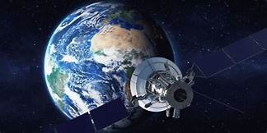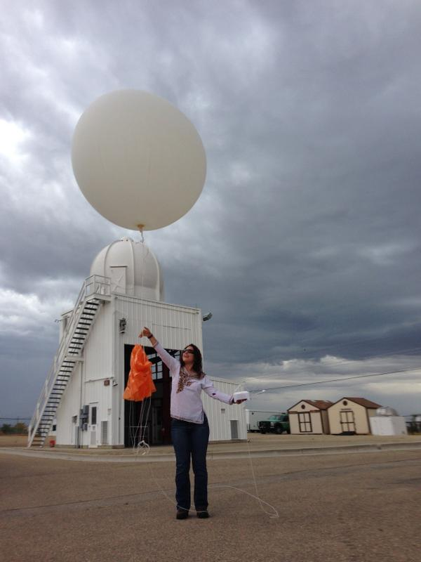
Remote sensing
Doppler radar
This image is Doppler radar showing a mesocyclone with the characteristic “hook echo” associated with tornadic storms.
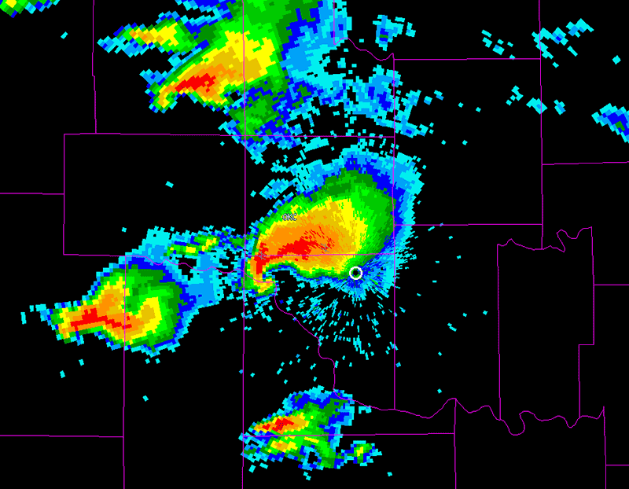
This is a mobile Doppler radar truck that is used by meteorologists and storm chasers to track potential tornadic storms.
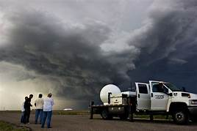
Upper air charts
These are some examples of upper air charts
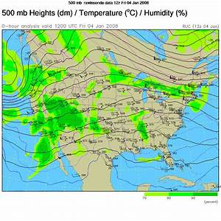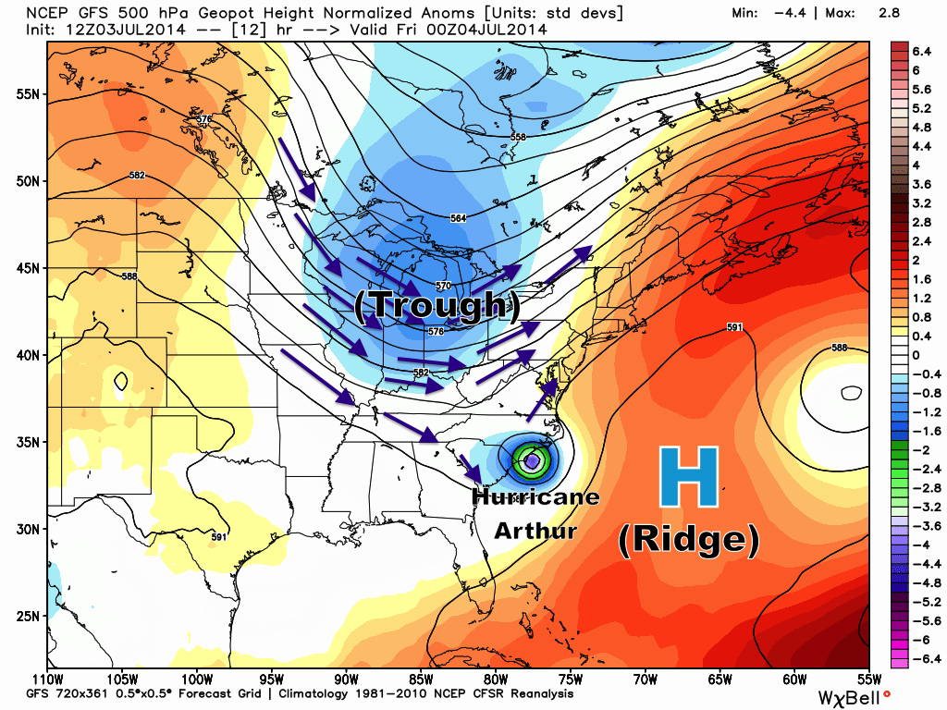
Stuve Diagram

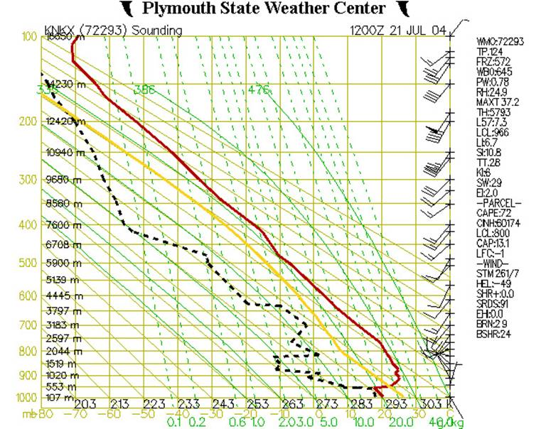
Stuve diagrams are used for forecasting the potential for precipitation and which type it will be.
Fronts
There are 4 major types of fronts:
- mT - maritime Tropical (moist and warm)
- mP - maritime Polar (moist and cold)
- cT - continental Tropical (dry and warm)
- cP - continental Polar (dry and cold)
Warm fronts and cold fronts are caused by air pressure. High pressure is associated with warm fronts, and low pressure with cold fronts.

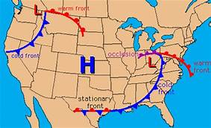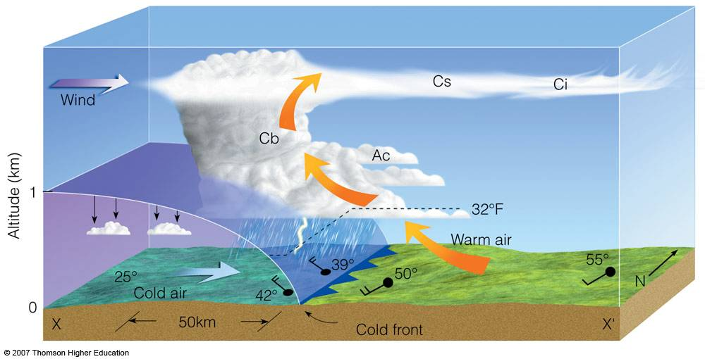


Forecasting methods

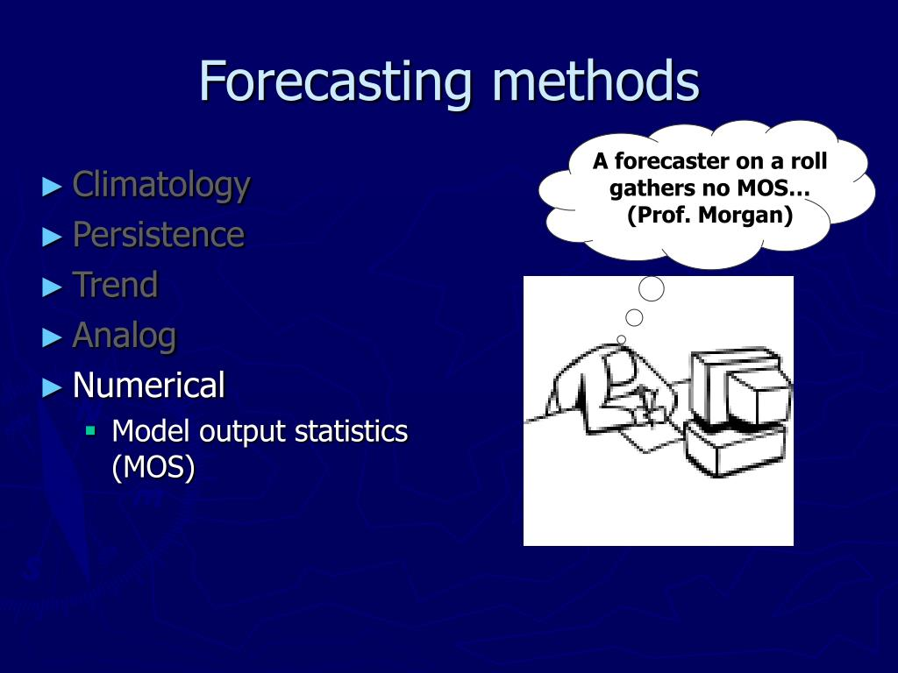
Climatology: involves taking an average of weather statistics over many years to create a forecast.
Persistence: is perhaps the simple way to make a forecast, which involves the assumption that the current conditions will remain/persist into the future
Trend: involves analyzing the speed, direction, precipitation, and pressures of fronts to predict where these conditions may occur in the future.
Analog: involves taking today’s forecast and comparing it to a similar forecast in the past and making an analogy to create a forecast.
Numerical: Involves using computer power to make forecasts. Super computers make forecast models based on predictions on many atmospheric variables such as temperature, pressure, wind, and rainfall.
Lake effect snow
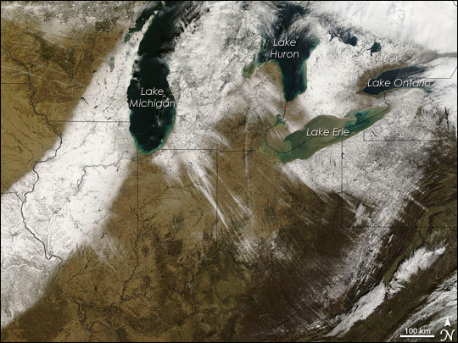
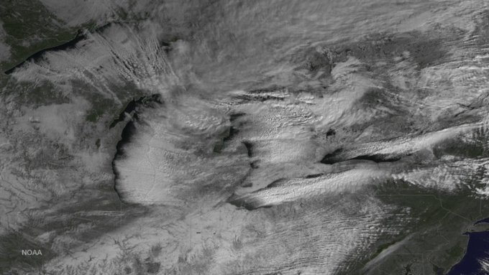
What is lake effect snow?
Lake-effect snow forms when cold, below-freezing air passes over a lake’s warmer waters. This causes some lake water to evaporate and warm the air. Then, the moist air moves away from the lake. After cooling, the air dumps its moisture on the ground, potentially becoming snow.

Thunderstorms
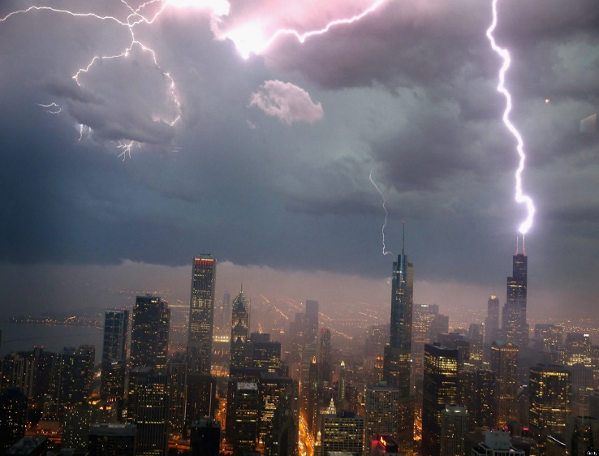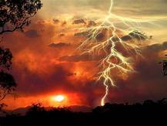
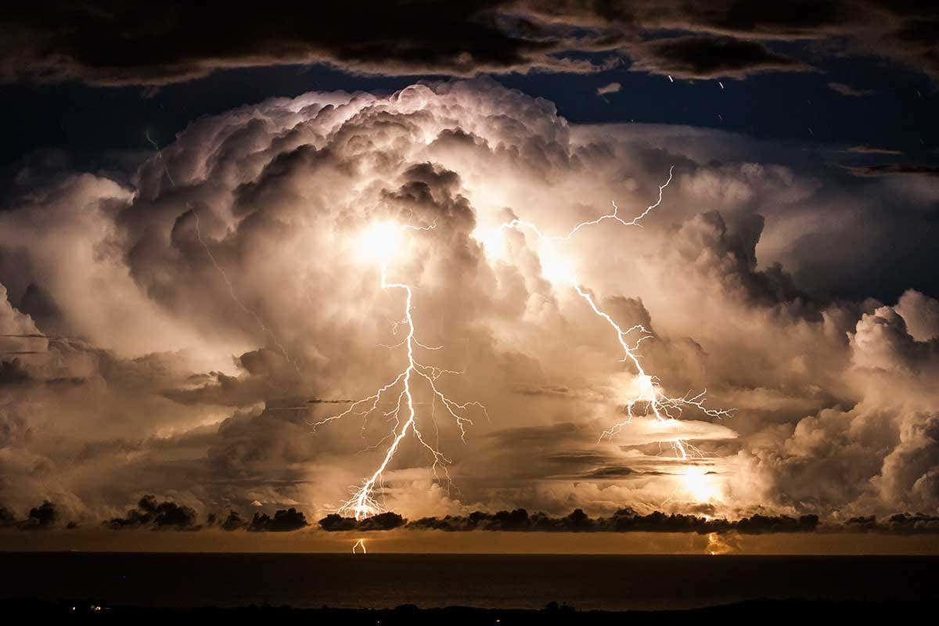
Thunderstorm ingredients include:
1. INSTABILITY 2. WIND SHEAR 3. LIFTING 4. MOISTURE
“A thunderstorm is a rain shower during which you hear thunder. Since thunder comes from lightning, all thunderstorms have lightning”. (https://www.nssl.noaa.gov/education/svrwx101/thunderstorms/)

Severe Storms, Lightning, Wind and Hail
Lightning
Every thunderstorm produces lightning, which on a national basis kills more people than tornadoes in a given year. Lightning kills around 100 Americans annually, with about 300 injuries. In Wisconsin and Minnesota, there have been many deaths and injuries over the years, most in areas such as camp grounds, although people have been injured indoors when talking on the phone.
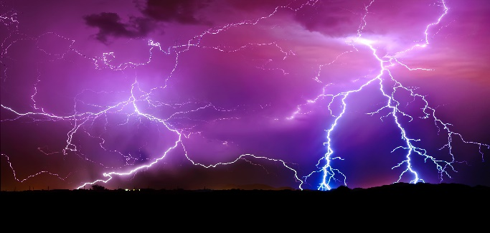
Hail
Is another product of thunderstorms that annually causes nearly one billion dollars in damage throughout the United States, many of the losses are incurred by farmers. The most common diameter is pea size, but hail can be as large as golf balls and baseballs. In extreme cases, hail can reach grapefruit size. Large hail stones fall at speeds faster than 100 mph and have been known to kill people.
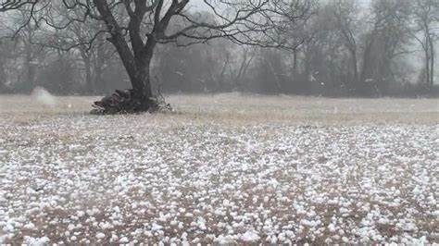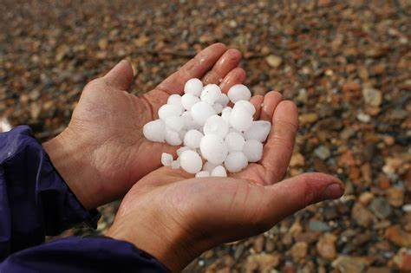
Wind
Thunderstorms can produce strong wind gusts. These straight-line winds have been known to exceed 100 mph. For this reason, you should treat severe thunderstorms just as you would tornadoes. Move to an appropriate shelter if you're in the path of the storm.

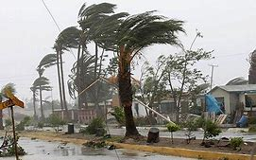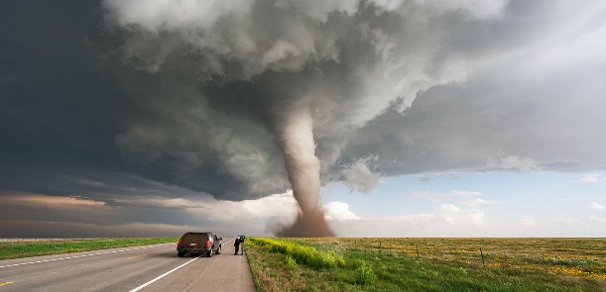
Tornadoes
A tornado is a narrow, violently rotating column of air that extends from a thunderstorm to the ground. Because wind is invisible, it is hard to see a tornado unless it forms a condensation funnel made up of water droplets, dust and debris. Tornadoes can be among the most violent phenomena of all atmospheric storms we experience.
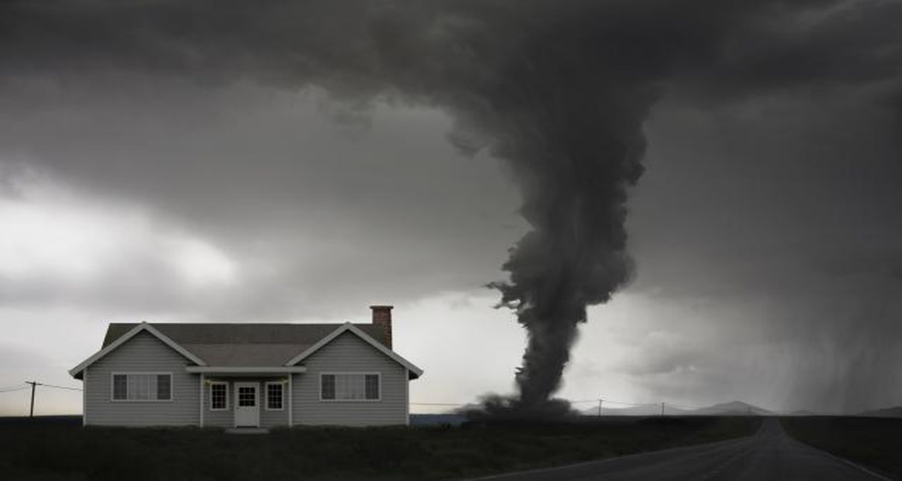
About 1,200 tornadoes hit the U.S. yearly. Most of them occur in “tornado alley”.

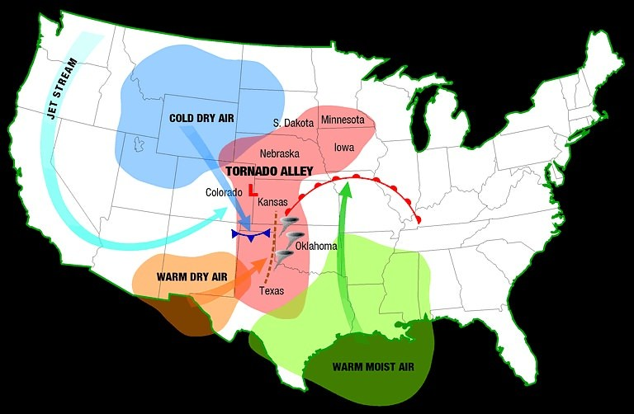
Hurricanes
A hurricane is a tropical cyclone with winds of 74 miles (119 kilometers) per hour or greater that is usually accompanied by rain, thunder, and lightning, and that sometimes moves into temperate latitudes
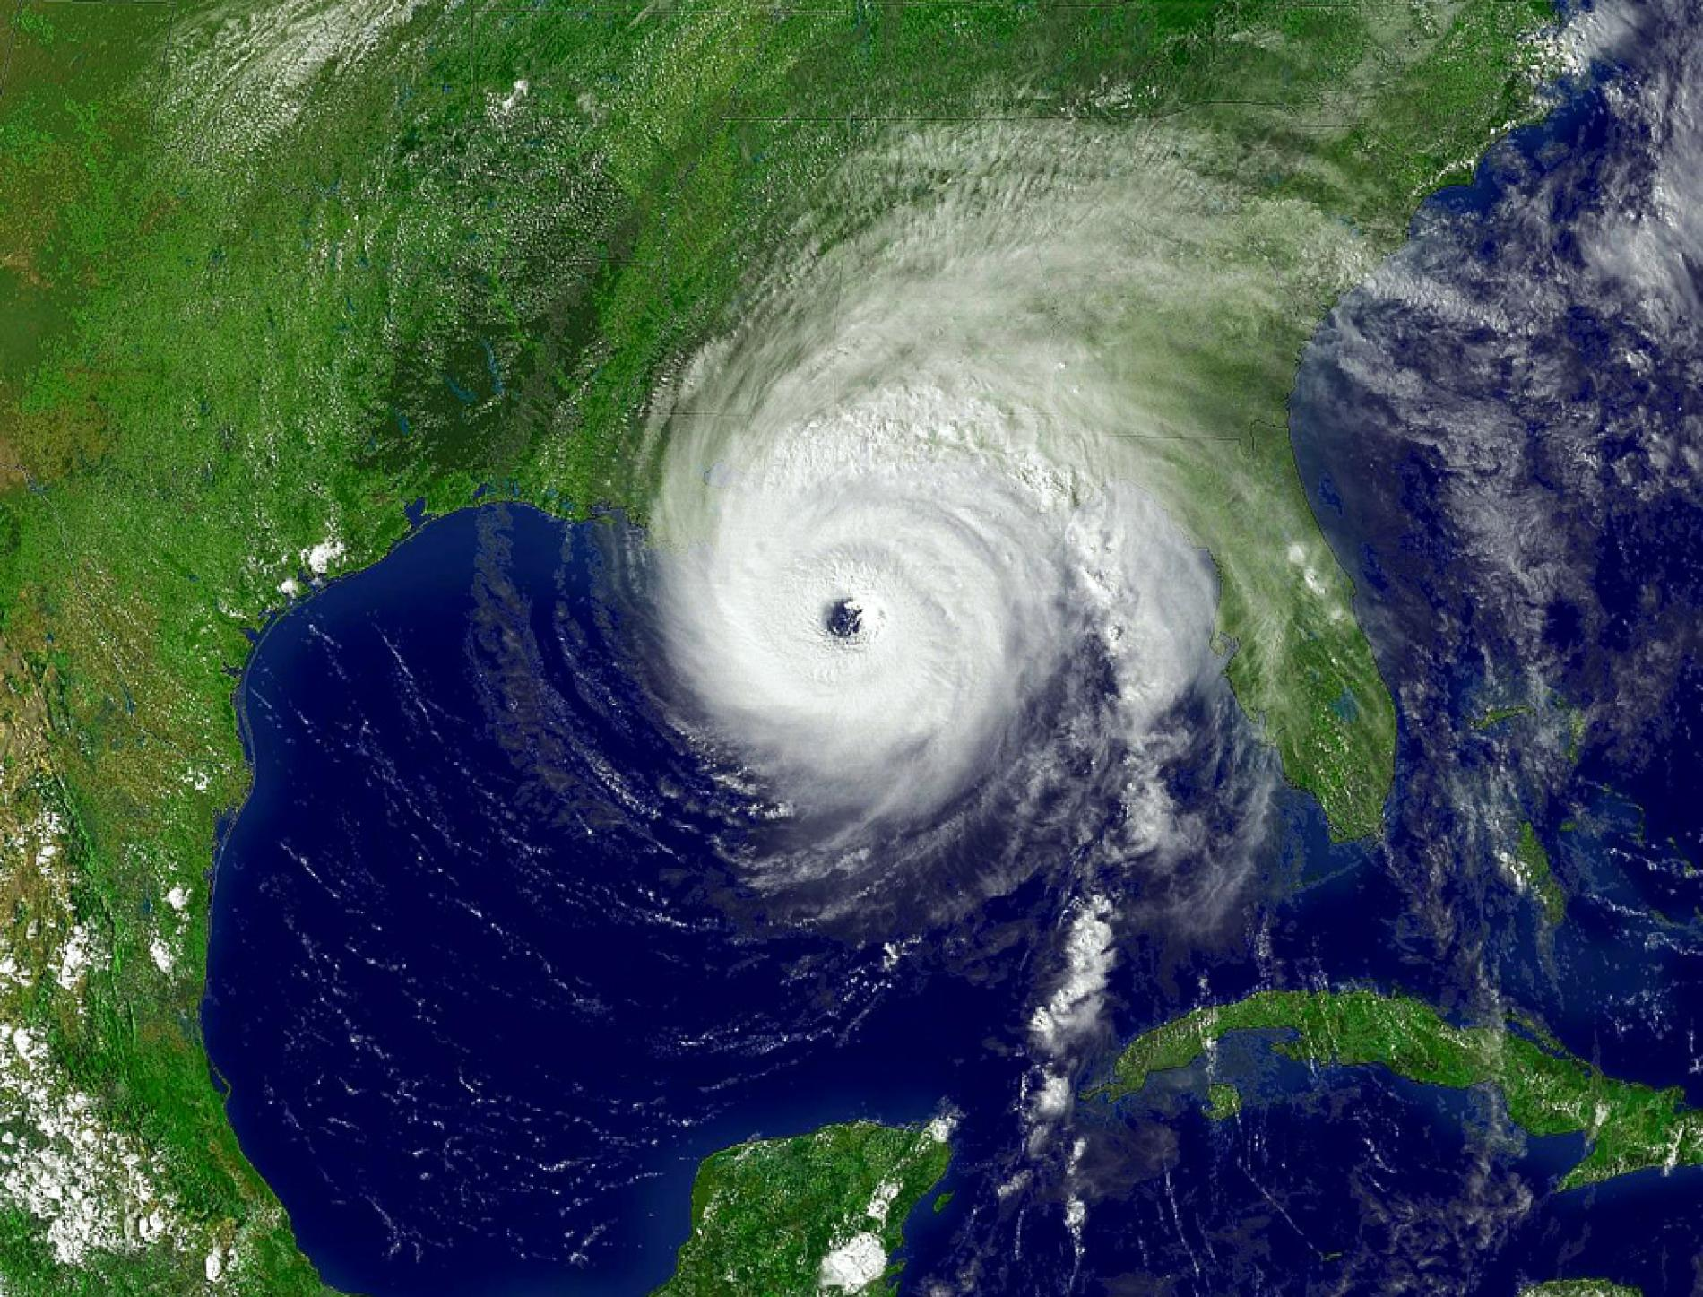

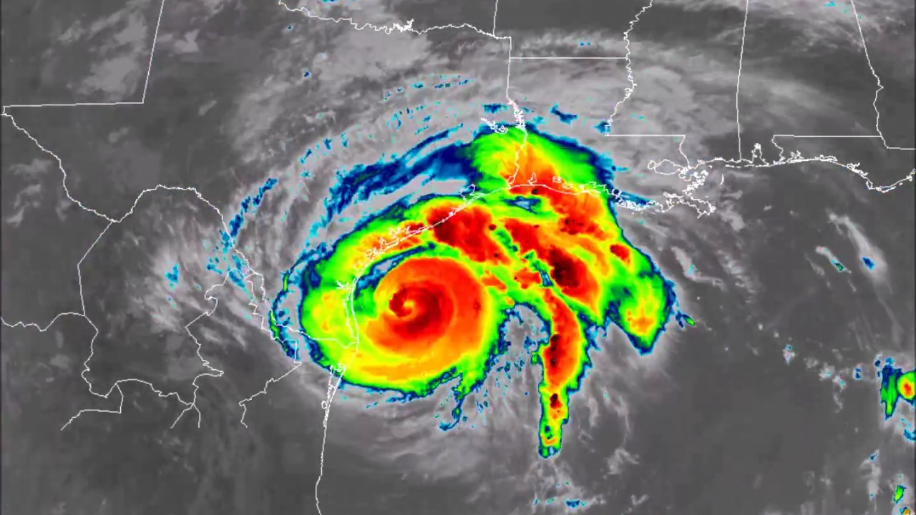
Climate Change
Climate change occurs when changes in Earth's climate system result in new weather patterns that remain in place for an extended period of time. This length of time can be as short as a few decades to as long as millions of years.
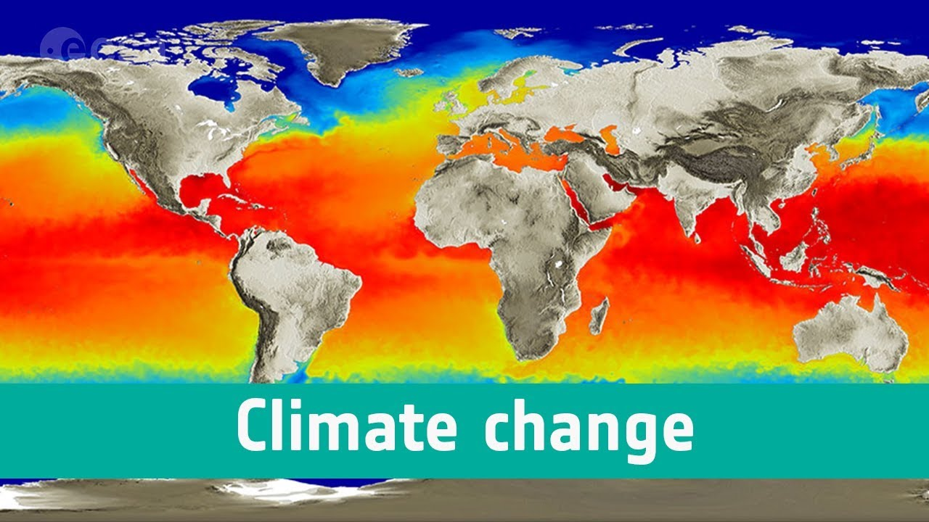
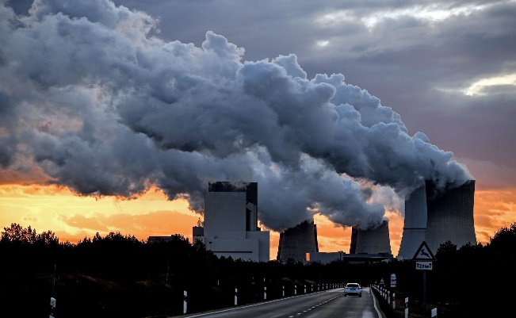
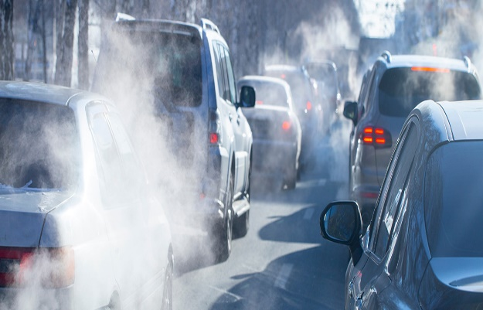
Carbon dioxide is a major contributor to the warming of the earth’s atmosphere. Most of it comes from the burning of fossil fuels Pollution created by the advancement of industrial production and the release of various chemicals into the atmosphere, also contribute to the problem.
We need to develop alternative energy sources to reduce the input of CO2 into the earth’s atmosphere, or face an uncertain future of what may include dire consequences.

