Robert B. Kiholm
English 2010
Jennifer Courtney
Salt Lake Community College
October 27, 2018

Gun Rights and the 2nd Amendment in America
The topic of gun rights and gun control is a very controversial issue. There are many opinions from both sides that are based on the history of the subject as well as how it’s relevant today. It is my contention that the 2nd amendment is correctly interpreted and is absolutely necessary to help preserve the freedoms we enjoy in our country. In this literary effort I will defend my position with persuasion based on research and statistical information. I will be as objective as I can and leave it to you the reader, to decide for yourself.

If you live in America and are exposed to some form of media, it’s virtually impossible to not hear of, or read about, the arguments either for or against the 2nd amendment. Ever since the founding of this great nation firearms have been an integral part of our history. They were a necessary instrument in our efforts to obtain our independence. The founding fathers realized the need to prevent an oppressive or tyrannical government from taking our freedoms away. That is how the 2nd amendment came into conception. However the 2nd amendment was meant to be more than just maintaining an armed militia to defend our country against enemies, as many say is the correct interpretation. It was designed to be a way for the people of this country to prevent our government from becoming what the British Monarchy was to us.
I found a perfect example of this scenario while conducting research on the 2nd amendment. Here is a brief synopsis of an article entitled, “The ‘Nice Girl’ Who Saved the Second Amendment” written by John J. Miller. The person the article was written about is named Joyce Lee Malcolm. She is a historian and a leading scholar on the 2nd amendment. The following quote sums up her feelings about gun control. “Something deep inside of me says that people never should be victims,” she says. “And they never should be put in the position of being disarmed by their government.” She earned the title of, “The lady who saved the 2nd amendment” because her work helped make possible the Supreme Court’s landmark Heller decision, which in 2008 recognized an individual right to possess a firearm. In Malcolm’s doctoral dissertation she wrote about King Charles 1 and the problem of loyalty in the 1640s. While doing her research she noticed that during the English Civil War, “The king would summon the local militia to turn out with their best weapons,” she says. “Then he would relieve them of their best weapons. He confiscated them. Obviously, he didn’t trust his subjects.” In 1689 the English actually created their own “Bill of Rights” that gave the citizens the right to have arms for their defense. “The English felt a need to put this in writing because the king had been disarming his political opponents,” she says. “This is the origin of our Second Amendment. It’s an individual right.”
Fast forward to today and we see arguments from gun control advocates that range from stricter gun law regulations, to banning firearms entirely and eliminating the 2nd amendment. On the other side we have advocates for gun rights that fully support the 2nd amendment, and typically resist any attempt at legislation that restricts what they deem to be their constitutional rights. So what is needed? Why are gun rights supporters so resistant to new firearm regulations? I researched this and found an article written by David T. Hardy that I think answers this question very effectively. The title is "Why Gun Owners Are Right to Fight Against Gun Control?" With a subtitle of, The anti-gun crowd doesn’t want “compromise.” They want confiscation and control.” In it is a description of a recent gun control proposal that was rejected by the Senate. The legislation would have enacted stricter background checks for gun purchases at gun shows or online. There were many who questioned why gun owners and their various organizations would resist such a limited measure. “Understanding the rejection requires understanding gun owners’ shared experiences. Compromise requires that both parties relinquish something. If your counterpart’s position is “give me this now, and I’ll take the rest later,” there is no real compromise to be had. Over decades, that has been precisely the experience of American gun owners.” In 1976 Pete Shields a man who is now the president of “The “Brady Campaign” described a plan to take small pieces of handgun rights with the ultimate goal of total handgun control. They estimated it would take 10 years to accomplish their goal. By 1990 they realized the plan wasn’t working so they shifted their objective to assault rifles. The change only served to remind gun owners of a lesson they had already learned and that was gun control advocates would go for any target of opportunity. “Any reasonable compromise would simply be a first step in a long campaign to make gun ownership as difficult, expensive, and risky as possible.”
So what would happen if we were to ban firearms here in the U.S.? There is no way to know for sure if the legislation would accomplish the goals of gun control advocates, but there are some eye opening statistics from other countries that may give us an idea of what would most likely happen.
If you look at the charts below you can see an example of what happened in Australia and the United Kingdom after legislation took guns away. The gun bans did nothing to prevent violent crime.

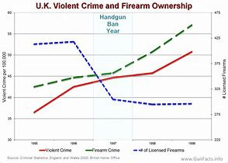
As you can see violent crime and firearm crime greatly increased in both countries after gun confiscation. One theory for this result is because only the honest law abiding citizens turned in their firearms, and all the criminals kept theirs knowing it would be “open season, or easy pickings” to prey on people that they knew had no guns to protect themselves. Even if the criminals didn’t have guns, the knowledge that no one else did either would only serve to embolden them to commit the violent crimes with some other type of weapon. These memes pretty much sum up the effectiveness of gun laws, in regards to criminals.
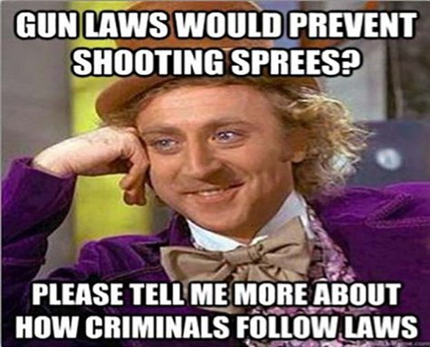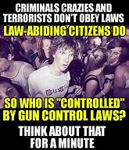

If then, gun bans aren’t the answer where does that leave us? The fact is firearms are here to stay so there has to be some compromise from both sides. One source I researched entitled, “A Teachable Moment for 2nd Amendment” addresses the complications of trying to enact gun control laws without infringing on other constitutionally protected rights. A group of student from West Wendover High School were asked to present, analyze, and synthesize mock gun legislation. They were asked to keep the debate civil as ideas from both sides were presented, and heated debates could potentially happen. One student presented an idea that involved screening for mental illness before the purchase of a firearm. Another responded, “That would violate the 14th amendment due process clause and the right to privacy by requiring medical checkups. Also what if that person was diagnosed with mental illness after already owning a firearm? The teacher playing devil’s advocate during the conversation chimes in and says, “So it’s my right to privacy vs your right to feel safe?” This is an example of how conflicting opinions and laws can make it difficult to enact effective legislation. Later the teacher confided that, “these were her two favorite moments in the lesson, because the students were grappling with the insight that Constitutional rights are interlocking and exist in relation to one another. The right to bear arms becomes difficult to regulate without bumping against rights in other amendments. It requires balancing collective and individual rights. And it shows why questions of constitutionality are so difficult--and so contested.”
During my research I made a trip to the “Rocky Mountain Gun Show” in Sandy, UT to ask various people there how they felt about legislating stricter gun control laws. As you might expect virtually everyone I spoke with was adamantly against any type of gun control legislation. As described in the previous article I mentioned, nearly everyone was worried about the old cliché, “If you give them an inch, they will take a mile!” There were a few people who conceded that tighter restrictions would be beneficial to help prevent many violent gun crimes. After all if you are a good law abiding citizen and meet the set requirements then you have no reason to worry about losing your firearm privileges right? There was one question I thought about after my experience at the gun show, that I wish I would have asked and that is why do you own a gun? I came across the graphic below that helps understand why people own guns.
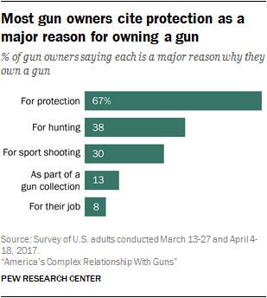
The graphic makes sense to me. There is something to be said for the added peace of mind gained by knowing that should something happen you could at least defend yourself or other people. There have been many publicized instances where concealed carry permit holders (CCP) have stepped up and engaged violent criminals armed with guns or other weapons and saved lives by neutralizing the situation. One story in particular took place recently in Salt Lake city, UT. A violent man was beating a Starbucks employee, when a frequent customer drew his attention away from the woman and ended up shooting him with his concealed carry gun to protect himself. It was fortunate for the woman that he was there and had the presence of mind and courage to help.
Gun owners are a different breed it seems. They are passionate about shooting and hunting. Being a gun owner and gun rights advocate, I understand their love of these activities. Shooting a firearm can be almost euphoric for some people. Most gun owners/collectors are always looking to find the latest, most high tech, and sexy gun out there to add to their collection. Hunting gets right down to the primal side of mankind. The feeling of stalking and killing an animal for meat on the table is very fulfilling for hunters. I presented this personal analysis of gun rights advocates/gun owners to help their opponents to perhaps understand, or at least have an open mind as to why they oppose anti-gun legislation. If nothing else it may help people open up a dialog that offers concessions from both sides in terms of new gun laws.
There is no way to understand how a person, family, or friend might feel if they lost a loved one because of gun violence. There is no way to know how we might react if faced with the same tragedy, unless we experienced it ourselves. It doesn’t seem irrational or unreasonable to expect a reaction of, “We need to take away all guns to solve this problem!” I truly believe that this will not solve the problem, and the statistics support my position. It’s unfortunate that many of man/womankind’s inventions, even when designed for good, are often used for violent purposes. Firearms are interwoven into our countries history and they will be for the foreseeable future. The political aspects of the argument are very much like legislation with bi-partisan politics. There are many common logical fallacies that are present in our country that pertain to gun control. An example is, “I don’t support murder of the innocent, and therefore I don’t vote Republican, Republicans often support the 2nd amendment. This is the kind of logic that prevents collaboration in government for effective gun laws. Working together is the only way to come up with effective solutions. Let’s hope that cooler heads and wisdom prevail in the efforts to create laws that will solve, or at least reduce many avoidable violent crimes and accidents in our great country.

Works Cited
Hardy, David T., Why Gun Owners Are Right to Fight Against Gun Control
The anti-gun crowd doesn't want "compromise." They want confiscation and control. July 18, 2018
"Why Gun Owner Are Right to Fight Against Gun Control"http://reason.com/archives/2013/07/18/why-second-amendment-supporters-are-righ
Miller, John J., National Review. Vol. 70 Issue 7, p25-27. 4/16/2018. http://eds.b.ebscohost.com.libprox1.slcc.edu/eds/detail/detail?vid=2&sid=e9ffe363-e10b-4599-b539-6dd1cf775397%40sessionmgr101&bdata=JnNpdGU9ZWRzLWxpdmU%3d#AN=128757576&db=f6h
Sawchuk, Stephen, A Teachable Moment for 2nd Amendment. Education Week. Vol. 37 Issue 24, p1-16. 3/21/2018,
http://eds.a.ebscohost.com.libprox1.slcc.edu/eds/detail/detail?vid=0&sid=2a8b426b-0c12-46a3-a09b-106d206c0238%40sessionmgr4009&bdata=JnNpdGU9ZWRzLWxpdmU%3d#AN=131442225&db=f6h
http://eds.b.ebscohost.com.libprox1.slcc.edu/eds/detail/detail?vid=0&sid=cca2129b-641d-429f-bc71-372bd08a3c08%40sessionmgr104&bdata=JnNpdGU
www.guncarrier.com Visual meme image.
https://johnrlott.blogspot.com/2012/08/some-notes-on-claims-about-australias.html Australian crime statistics image.
www.GunFacts.info UK crime statistics image.
pewresearch.org Graphic: “Reasons for owning a gun”

