Gun Rights and the 2nd Amendment in America

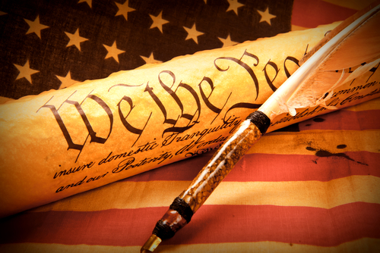
On December 15, 1791 the 2nd amendment was ratified. The founding fathers realized the need to prevent an oppressive or tyrannical government from taking our freedoms away.
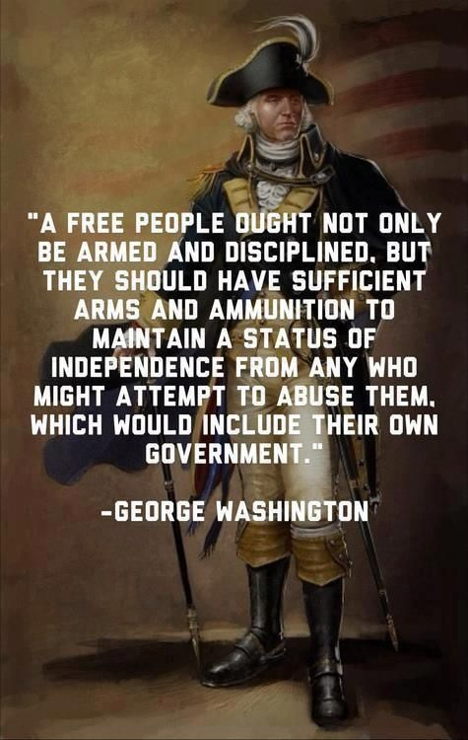
Ever since the founding of this great nation firearms have been an integral part of our history. They were a necessary instrument in our efforts to obtain our independence.

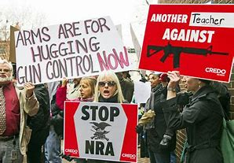
Today we see arguments from gun control advocates that range from stricter gun law regulations, to banning firearms entirely and eliminating the 2nd amendment. On the other side we have advocates for gun rights that fully support the 2nd amendment, and typically resist any attempt at legislation that restricts what they deem to be their constitutional rights.


If you look at the statistics from two countries that have banned guns, it’s clear the results are far from what would be considered successful. In fact, the number of violent crimes greatly increased in both the U.K. and Australia.


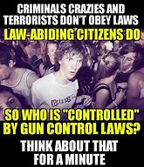

What are the reasons people want to own firearms? The following graphic helps put that into perspective.

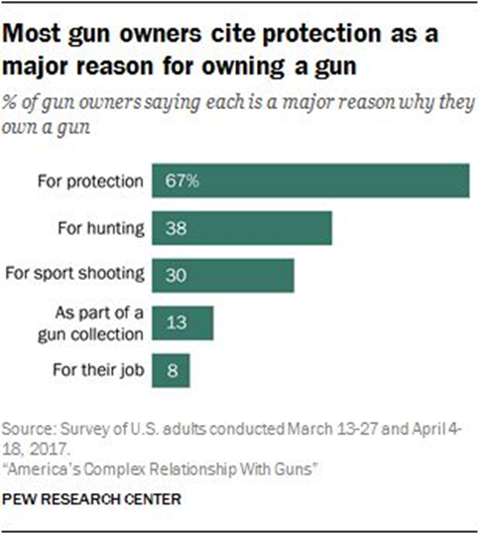
The graphic makes sense to me. There is something to be said for the added peace of mind gained by knowing that should something happen you could at least defend yourself or other people. There have been many publicized instances where concealed carry permit holders (CCP) have stepped up and engaged violent criminals armed with guns or other weapons and saved lives by neutralizing the situation. One story in particular took place recently in Salt Lake city, UT. A violent man was beating a Starbucks employee, when a frequent customer drew his attention away from the woman and ended up shooting him with his concealed carry gun to protect himself. It was fortunate for the woman that he was there and had the presence of mind and courage to help.


There is no way to understand how a person, family, or friend might feel if they lost a loved one because of gun violence. There is no way to know how we might react if faced with the same tragedy, unless we experienced it ourselves. It doesn’t seem irrational or unreasonable to expect a reaction of, “We need to take away all guns to solve this problem!” I truly believe that this will not solve the problem, and the statistics support my position.
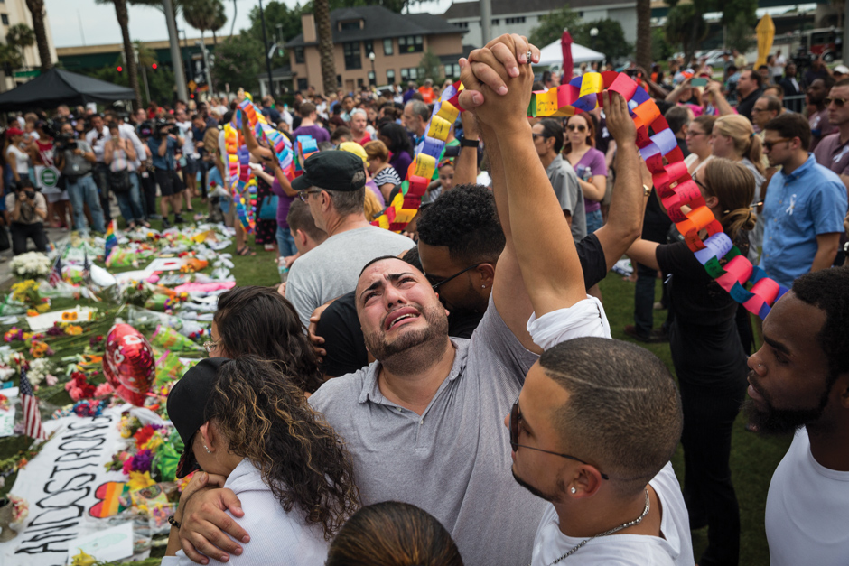

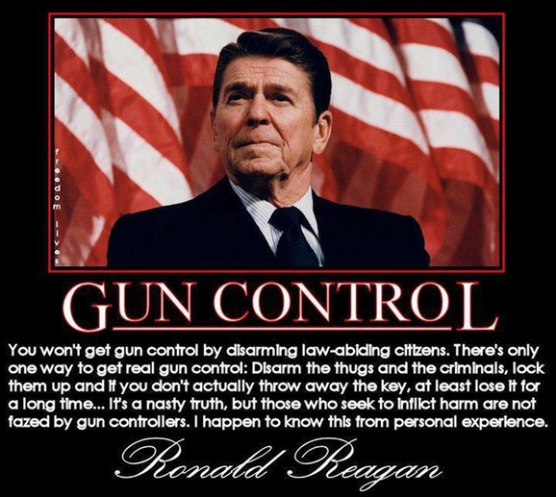
Firearms are interwoven into our countries history and they will be for the foreseeable future. The political aspects of the argument are very much like legislation with bi-partisan politics. There are many common logical fallacies that are present in our country that pertain to gun control. An example is, “I don’t support murder of the innocent, and therefore I don’t vote Republican, Republicans often support the 2nd amendment. This is the kind of logic that prevents collaboration in government for effective gun laws. Working together is the only way to come up with effective solutions. Let’s hope that cooler heads and wisdom prevail in the efforts to create laws that will solve, or at least reduce many avoidable violent crimes and accidents in our great country.

