Salt Lake Community College

Making a Difference in Our Community

Robert B. Kiholm
English 2010-F18
Jennifer Courtney
September 20, 2018

There are many people in our community that don’t have a place to call home. The reasons for this are as diverse as the people who face them. It seems that most of us who don’t have to deal with this problem seldom look beyond our circumstances. The truth is there are many compassionate people who spend their time trying to make a difference. Having performed some research on the subject, I have learned that there are in fact many organizations and corporations that are engaged in a concerted effort to make a difference in local communities.
One of these, The Utah Non-Profit Housing Corporation (UNPHC) has a mission to provide housing for low income people and families. This is a very valuable resource for many who would otherwise not be able to have a place to live. Housing is just one of the problems some families face. Often people in these circumstances are addicted to drugs or alcohol, and living on the streets. Some of the side effects from these issues are violence, abuse, a lack of food or clothing, and the necessities of life. Fortunately there are many organizations that are affiliated with the (UNPHC) that help people in these situations. The help available covers a broad range that includes, but isn’t limited to: food banks, counseling, homeless shelters, employment assistance, health care resources, and access to subsidized housing with low interest loans for low income people and families.
What are some the reasons that finding affordable housing is becoming more and more difficult? Let’s examine that. It seems that the cost of housing here in Utah is growing much faster than the wage of low income families. A report from the National Low Income Coalition has stated that, “people earning minimum wage would need to work 94 hours a week to be able to afford a two-bedroom apartment at fair market rent in the state. (McKenna AP Regional State
Report Utah Deseret News 6/15/2018)
As you can see from the graphic below, the gap between wages and the cost of housing in Utah is virtually unbridgeable. In fact based on this information, and on a 40 hr. work week, the lowest wage a person could make is roughly $17.02 /hr. to afford a 2 bedroom apartment in Utah.
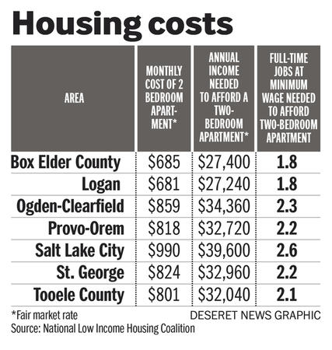
Where does that leave the families trying to live on a low income? That’s where corporations like the (UNPHC) can help. The way corporations like this are able to produce low-income housing is through federal government subsidies. The program is called the “Low Income Housing Tax Credit or (LIHTC)”. It provides investors with a dollar for dollar tax credit for money invested. While this program is beneficial for low income families, it is costly for taxpayers at approximately 8 billion dollars a year. There is another idea that has been presented where apartment landlords would receive lump sum grants from government entities in exchange for keeping rents lowered for income qualified renters for say 30 years. It has been deemed that landlords would be happy to receive the lump sum upfront, and the government would save tax money as well. With both of these options on the table the (UNPHC) has the means to provide
housing for people in need. There was one more research source that mentioned a brilliant idea for low-income families to lower the costs of home ownership. The program allows the future homeowner to actually help with the building process of their new home which would satisfy the down payment portion of the home and also reducing the overall cost by 25%. I first noticed the program listed in the (Janesville WI Gazette). I decided to do some local research to see if something similar is available in Utah. It turns out there are several local programs that offer essentially the same thing for qualifying income families. (utahhomegroup.com)
Now that we have taken a look at the low-income housing crisis here in Utah, and potential solutions for it, perhaps we should address the programs that are supported by the (UNPHC) affiliates. There is an extensive list of organizations listed on the Utah Non-Profit Housing Corporation website. All of these groups are designed to help with all Utah families’ needs not just the low-income sector. Homelessness has many unfortunate side effects. It can become a cycle in families that creates depression, issues with self-esteem, health issues, and struggles for children in school to name just a few. The (UNPHC) partners provide sources of assistance for these people. If you look at the numbers from 2005-2015 in the following chart, it’s clear that the local community efforts are making a difference. That’s a good sign for Utah, but unfortunately with the most recent hike in housing costs the statistics will most likely rise up again. Programs like these are needed more than ever if we are going to make a difference.
Along with the efforts from these organizations, Utah has taken an approach called “housing first”. The plan involves getting the chronically homeless people into housing first, and then trying to address other potential issues such as mental illness or drug addiction through counseling. The odds of success are much greater because the homeless that have been helped no longer have to have to face life sleeping on the streets. The good news is it’s clear that there is compassion and motivation here in Utah.

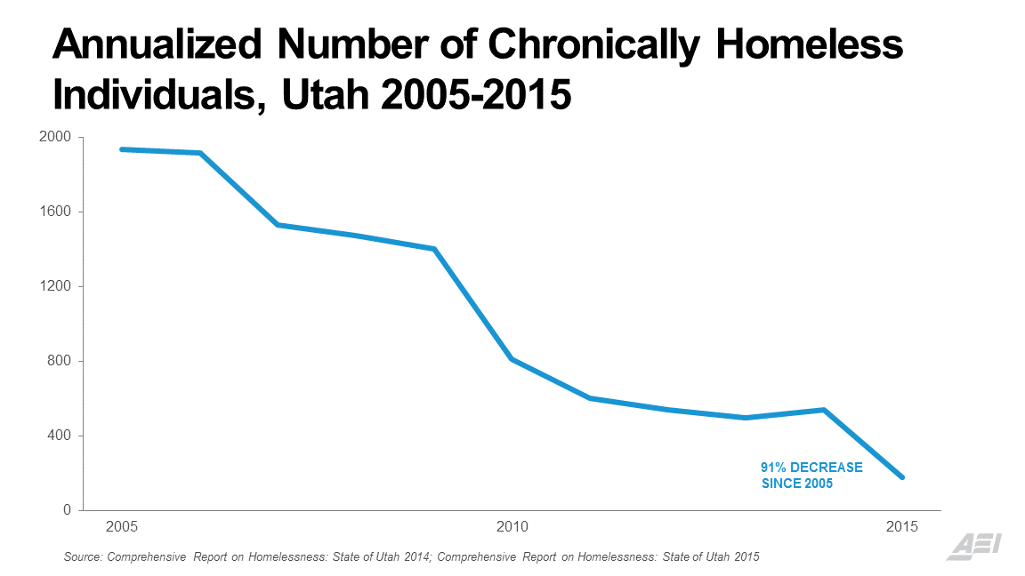
It shows in the many organizations created to help the people in our community who are in need.
Recently there have been many changes here in Salt Lake City that are affecting the homeless. There are ongoing efforts to change the face and perception of certain “problem areas”. Along with the homeless shelter in the downtown area being relocated, there is a concerted effort to help the homeless population there find help with possible housing or with drug or alcohol addiction as mentioned before. These community organizations are vital to the success of this effort. Utah has become somewhat of a posterchild for the nation because of these efforts and there relative success. It’s time for us to come together as citizens of Utah to help where we can. In my experience, there are few things in life that feel better than helping someone in need.

Works Cited
Ames, Marie. "Nailing Down Home Costs". Janesville Gazette, the (WI), Database: Newspaper
Holgersson-Shorter, Helena. "Helping the Homeless In School and Out". EDUCATION DIGEST Date: January 1, 2010
Lockhart, Ben. Report: 94- hour workweek at minimum wage to afford a 2 bedroom apt. In Utah. https://www.deseretnews.com/article/865683214/Report-94-hour-workweek-required-at-minimum-wage-to-afford-2-bedroom-apartment-in-Utah.html June 18, 2017.
Park, McKenna. "Utah Housing Prices Rising Faster than Wages, report says".
AP Regional State Report - Utah. 06/15/2018.
Profile, Mike. http://www.utahhomegroup.com/six-county-sweat-equity-program/Source Plus11/17/2007.
Roberts, Alexander. "A Different Approach to Creating Affordable Housing".
Westchester County Business Journal. 8/13/2018, Vol. 54 Issue 33, p12-12. 2/3p.
Utah Non-Profit Housing Corporation. https://unphc.org/

